End of Semester 1 Project Report
Muhammad Hamza Taher, 201723236
Contents
End of Semester 1 Project Report 1
Semester 1 Progress 1
Plan over the Christmas holidays 2
Plans for next semester 2
Image of Current circuit 3
Circuit diagram 3
Code Link Diagram 4
Block diagram 5
Web page 5
Extra Images 6

Semester 1 Progress
Overall testing of all components haven been done, there are still some issues with the heart rate and blood oxygen due to hardware and software issues. However, the temperature and air pressure sensor are functional along with the LCD displaying data.
Integration has been achieved for majority of components as they have been combined with all pin connections to the Pi Pico W which displays the information on the LCD of two sensors and allows the potentiometer to control the motors. It also has the speaker connected to make noise when certain data passes the set limits.
The motor system using a basic servo has been achieved with correct control of the speed and angle of socialization via potentiometer. However further testing is still happening with the Tower Pro Servo motor due to power issues.
Integration in code has also been achieved as the main program accesses sensor and motor sub files while utilising the speaker for noise interrupts.
3D design of the compression mechanism using the servo motor has started in working out the best design for the given size of the compression bag.
The webpage has been created and accessible using the web address. It was done using my personal hotspot to get around connecting through Eduroam.

Plan over the Christmas holidays
Further web work will be done such as changing the size of text and colour scheme for better readability. A username and password protection layer will be added to the webpage to make it more secure.
A testing plan of what needs to be calibrated and how will be developed across the holidays and exam season, ready for semester 1.
I will begin to do more research into the power supply of the device and how it can allow for it to be used while charging.
More thought will be put into how it can be used in areas with poor Wi-Fi connections.

Plans for next semester

As stated, next semester’s tasks in order are:
- Further heart rate sensor work
- Calibration
- Battery design
- Web connection via web sockets
- Data connection research in low Wi-Fi areas
- Further 3D design of ventilator
- Box design
- Final testing
- Poster design
- Bench inspection preparation

Image of Current circuit
The circuit shows the current layout if what has been achieve din assigning pinpoints based on i2C values, power, and signals all to the single microcontroller.
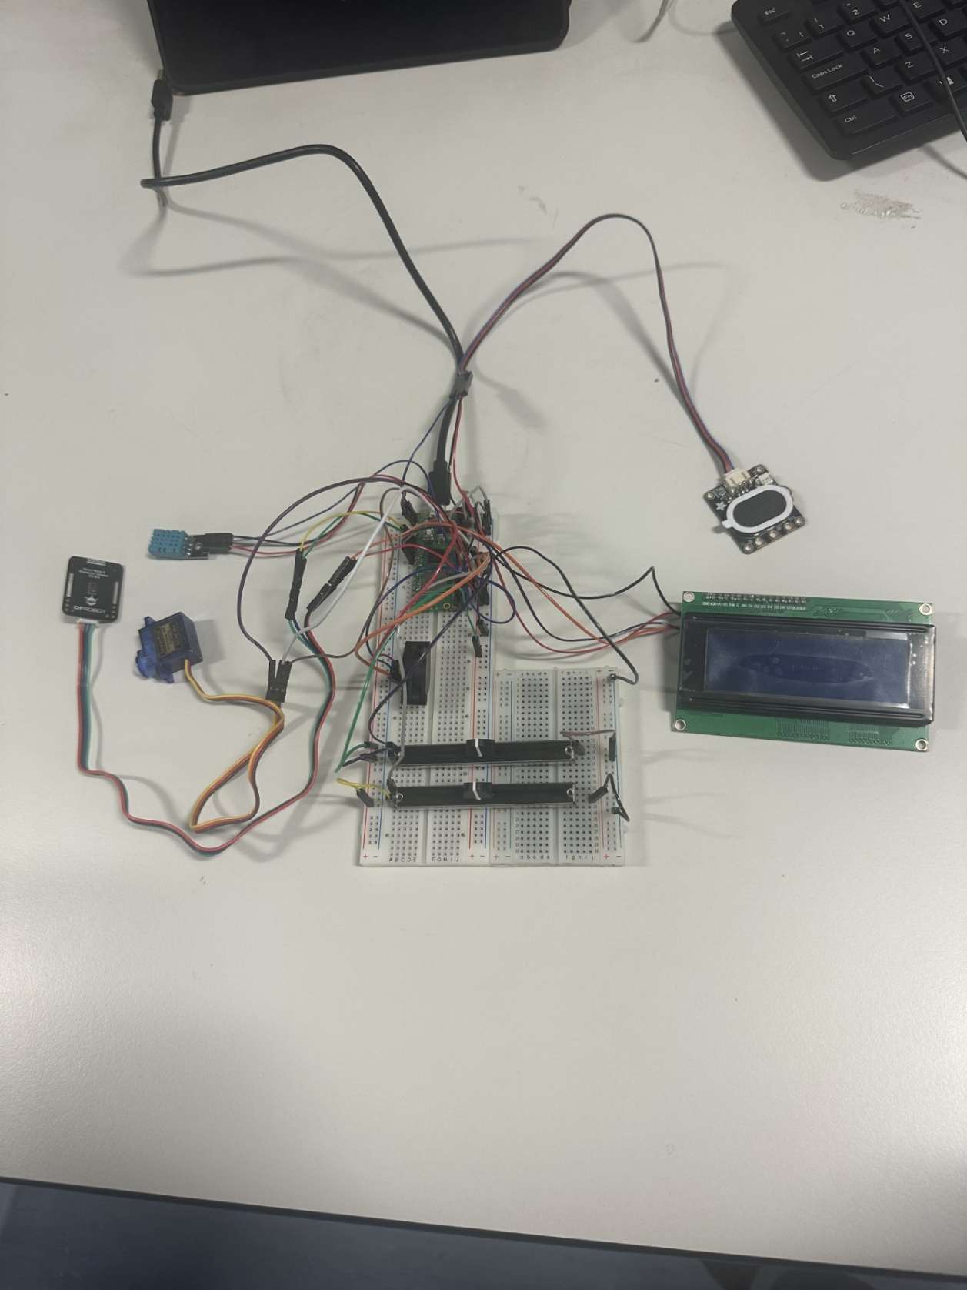

Circuit diagram
This circuit diagram is overall complete apart from the heart rate sensor which will have its pin set up changed.
In semester 2, a PCB will be designed to allow for better connection of the components, microcontroller, and battery supply. This will include pull down resistor with centralised voltage and ground points for better circuit design.
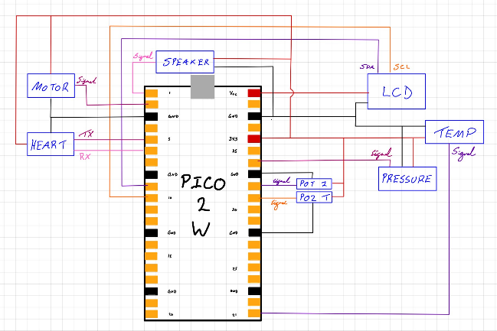

Code Link Diagram
This shows each micro python file and how they relate to others such as being called. This is broken into the speaker being used in each sensor code.
Sensor and motor are accessed by the main code which then works along side other files to display the data on the LCD and the webpage using the respected files.
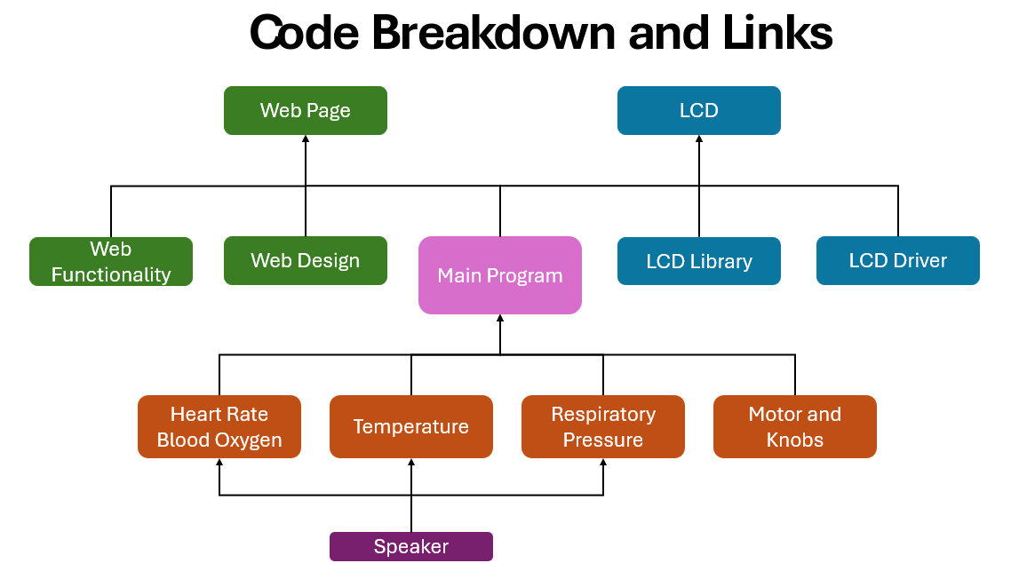

Block diagram
The block diagram shows the overall action of the device as data enters from the sensors and the buttons/Kobs into the microcontroller. This is then converted and outputted through motor movements, speaker sounds, and the displays.
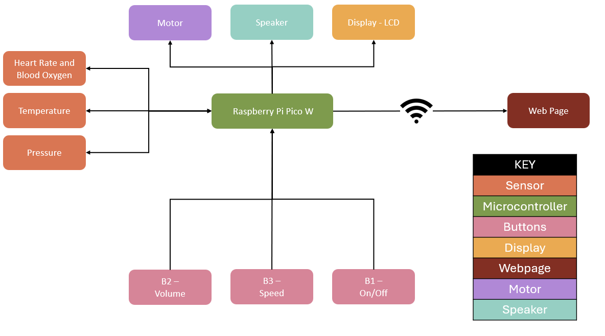

Web page
Web page has been developed using HTML and CSS embedded Thonny itself this has web sockets attached but not yet connected to the sensor data itself as the webpage currently just holds placeholder text. Live data transmission will be implemented next semester.
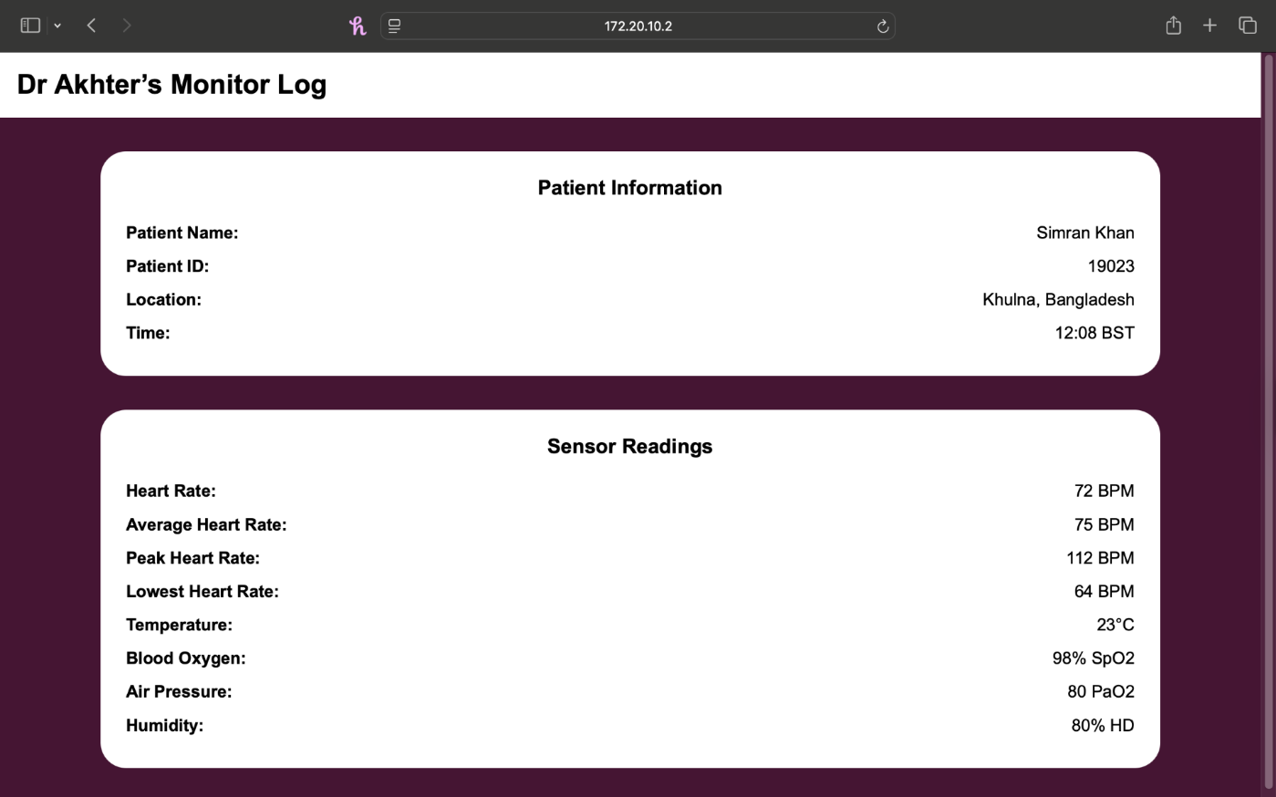

Code for the webpage (HTML and CSS) only
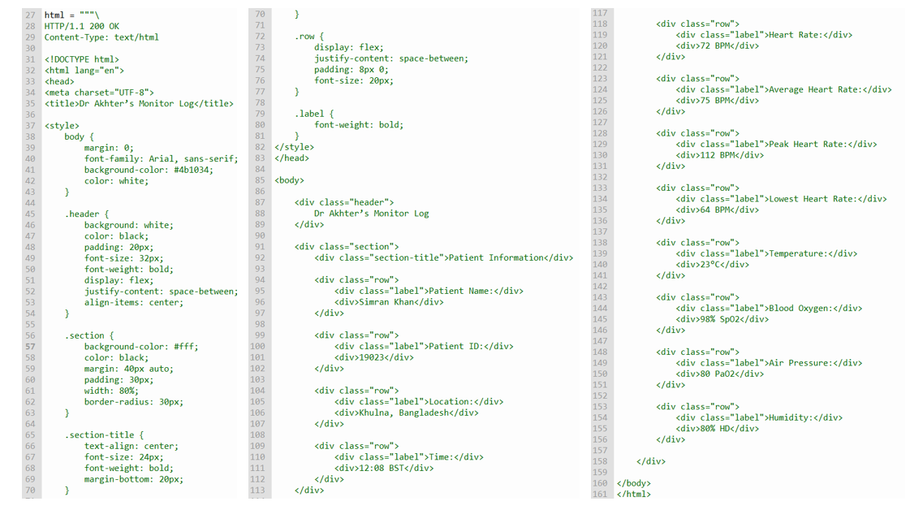

Extra Images
Current Thonny Files
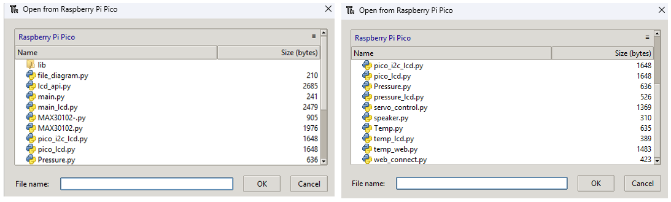

Heart Sensor (left), Temperature Sensor (middle), Air Pressure Sensor (right)
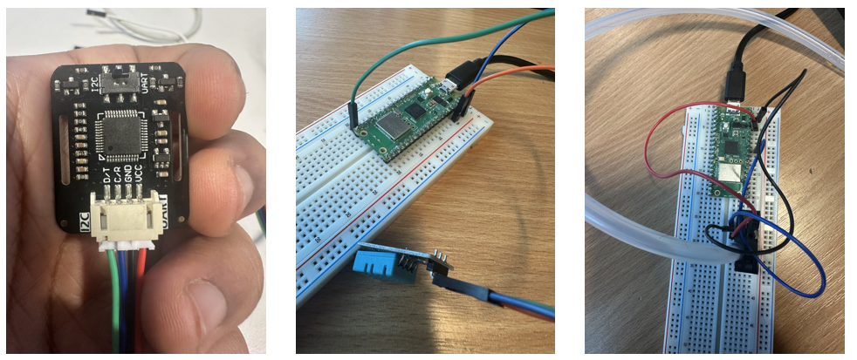

Speaker (left), Potentiometer Controlled Motor (middle), LCD (right)
